Title of your abstract is here (Bold, Times New Roman, 16 font)

(Times 12 font, Center) Author A¹, Author B¹, Author C² and Author D^{1,2}

Presenting author: Taiwain
Email: WelcomeToTaiwain@edu.tw (Times New Roman, 10 pt., centred)

¹(Times 10 font) Department of Materials Science and Engineering, Name of University/Institute/Company, City, Country
²Department of Materials Science and Engineering, Name of University/Institute/Company, City, Country (Times New Roman, 10 pt., Justify)

Keywords: first, second, third… (max 5 keywords, Times New Roman, 10 pt.)

This instruction is formatted in accordance with the style requirements. All abstracts must be written in English. Only Word (.doc or .docx) or open format (.odt) files are accepted. Each abstract should consist of maximal two pages and is limited in 350 words. The text should be written in Times New Roman, 10 pt., Justify, at 1.15 line spacing. Formulas and special characters can be used, but special care should be taken that these do not change the line spacing. It is not necessary to use abbreviations in the abstract. The abstract should contain text, formulas, tables and figures. References are referred to as [1] in the text and should be listed at the very end. The left and right margins should be 25 mm; the top and bottom margins should be 20 mm.
Leave a blank line (16 pt.) between the title and the author list, between the author list and the e-mail of the presenting author, between the keywords and the first line of the text and between text and references. Leave a blank line (16 pt.) between the e-mail of the presenting author and affiliations and between the affiliations and the keywords. References, including all author names, title, Journal, Volume, Year and Page, should be written in Times New Roman, 10 pt. at a single line spacing and listed in sequence of appearance [1, 2,…].

Figure 1 (a) The image should be center position and the spacing of image should be at single line spacing. (b) The caption should be written in Times New Roman, 10 pt., Justify, at 12pt line spacing.
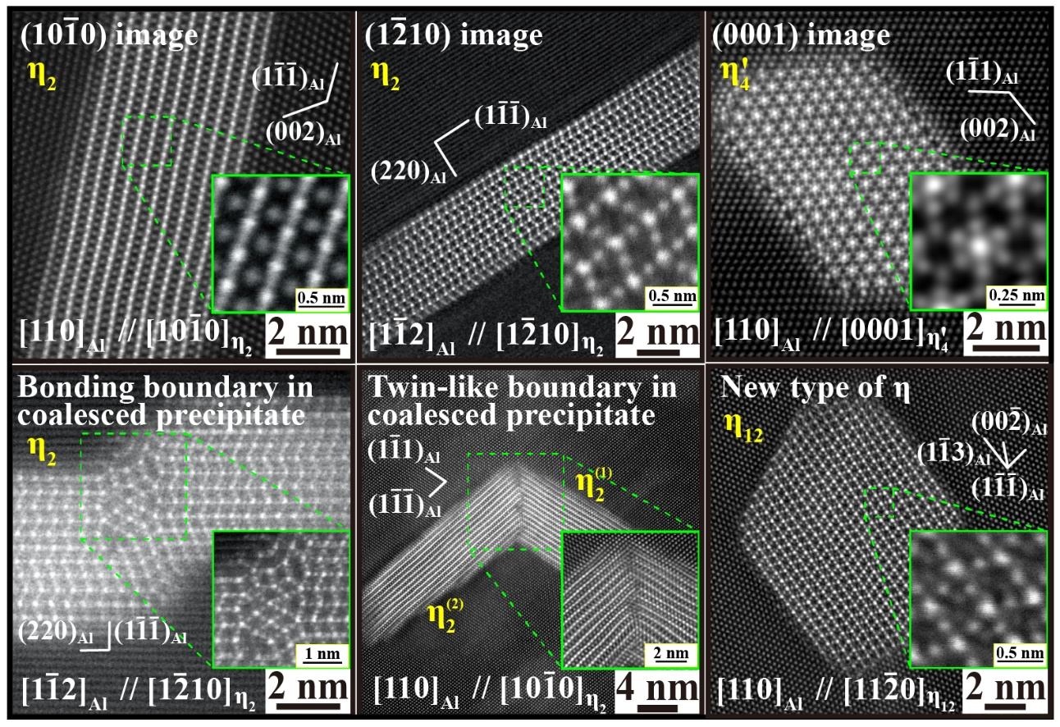
Figure 2 (a) The image should be center position and the spacing of image should be at single line spacing. (b) The caption should be written in Times New Roman, 10 pt., Justify, at 12pt line spacing.

Reference:
[1] T.-F. Chung, S.-Y. Lu, Y.-S. Lin, Y.-L. Li, P.-H. Chiu, C.-N. Hsiao, C.-Y. Chen, C.-L. Kuo, J.-W. Yeh, S.-H. Wang, W.-S. Lee, J.-R. Yang, Hierarchical nanotwins in Fe₂₇Co₂₄Ni₂₃Cr₂₆ high-entropy alloy subjected to high strain-rate Hopkinson bar deformation, Mater. Charact., 185 (2022) 111737.
[2] T.-F. Chung, Y.-L. Yang, M. Shiojiri, C.-N. Hsiao, W.-C. Li, C.-S. Tsao, Z. Shi, J. Lin, J.-R. Yang, An atomic scale structural investigation of nanometre-sized η precipitates in the 7050 aluminium alloy, Acta Mater., 174 (2019) 351-368.

